

**Rajokri Institute of Technology, DSEU**

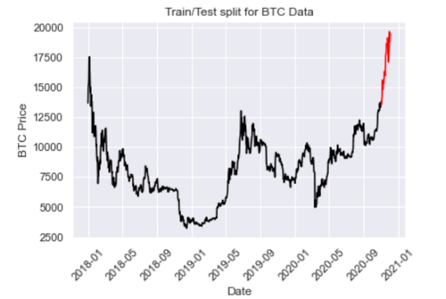

**Time Series Forcasting**

Practical File

**B.Sc. DATA ANALYTICS 2023-26**

Name: Pawan Parida

Roll No.: 231112028098

Semester: 5th

Subject: Time Series Foracasting

Subject Faculty: Mr. Pipul kumar